Ex No: 3 – EXAM REGISTRATION SYSTEM NAME: ROHINI(192420054)

USE CASE DIAGRAM:
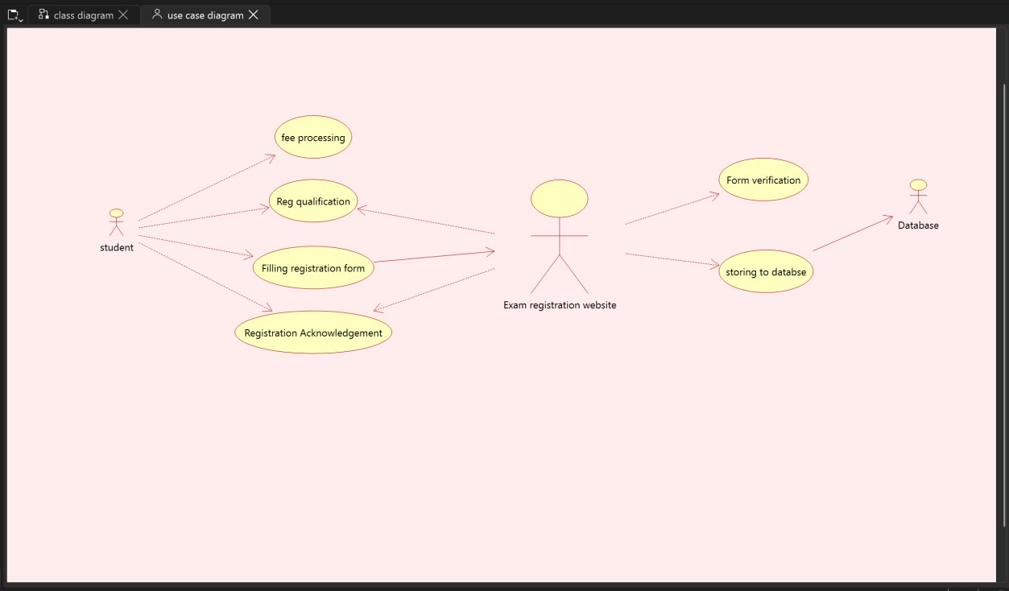

CLASS DIAGRAM:
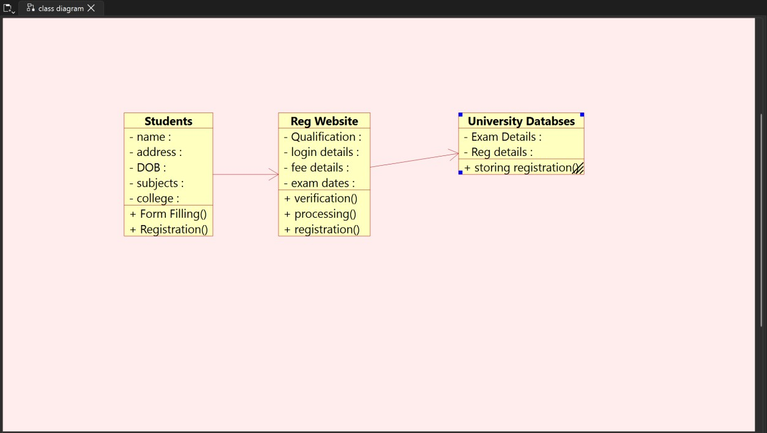

ACTIVITY DIAGRAM:

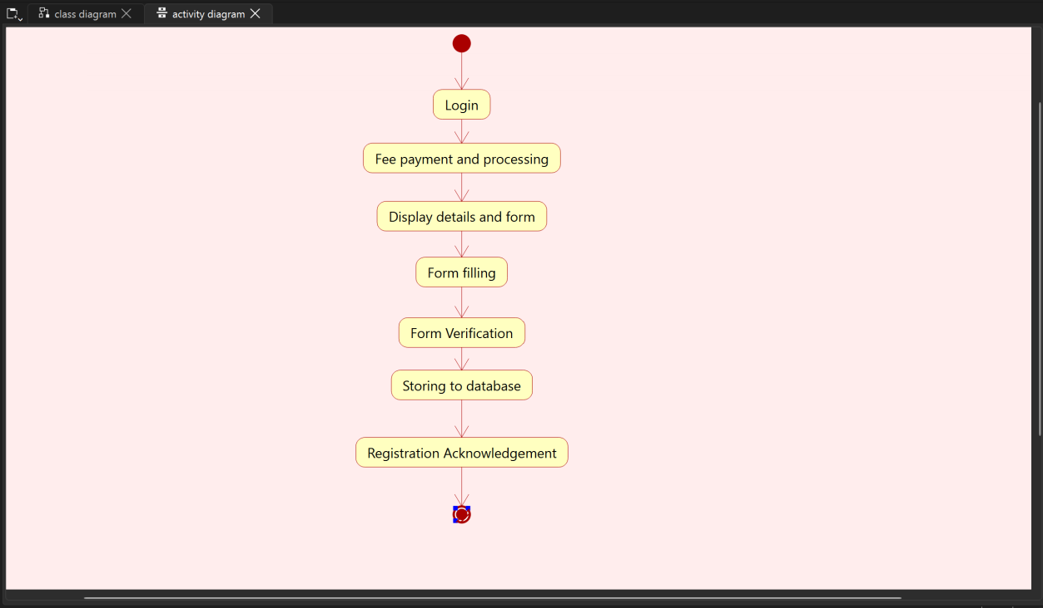

DEPLOYMENT DIAGRAM:

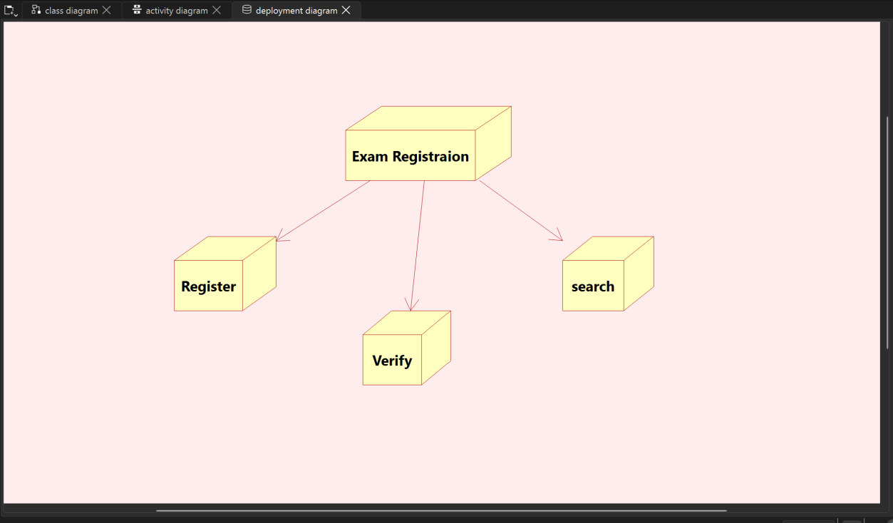

SEQUENCE DIAGRAM:

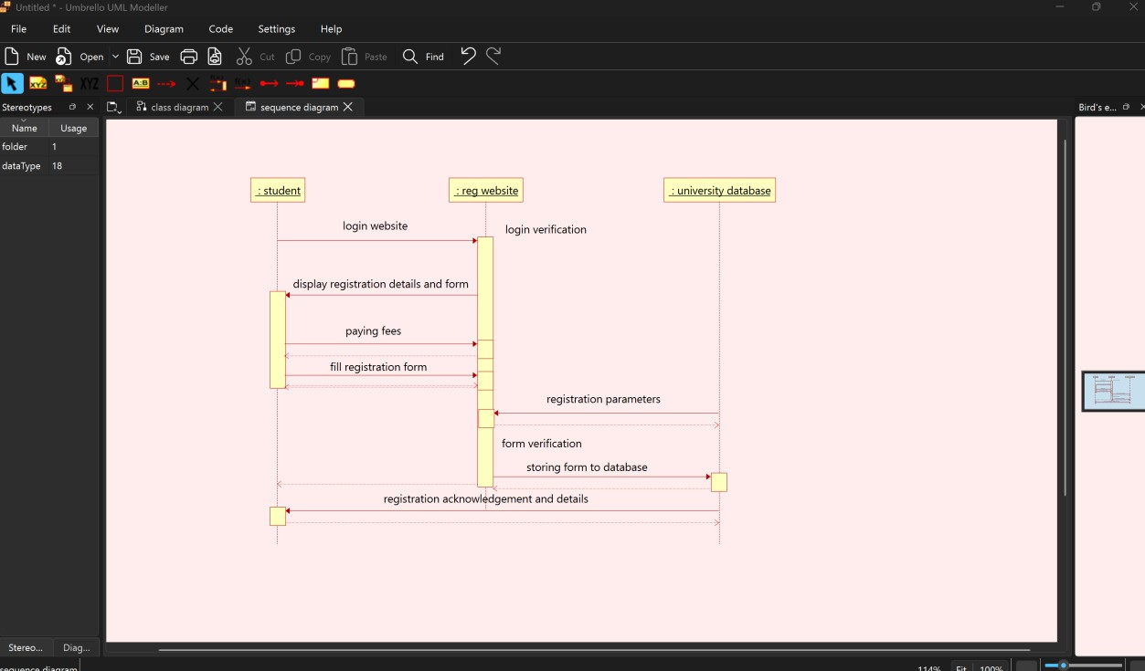

COLLABORATION DIAGRAM:
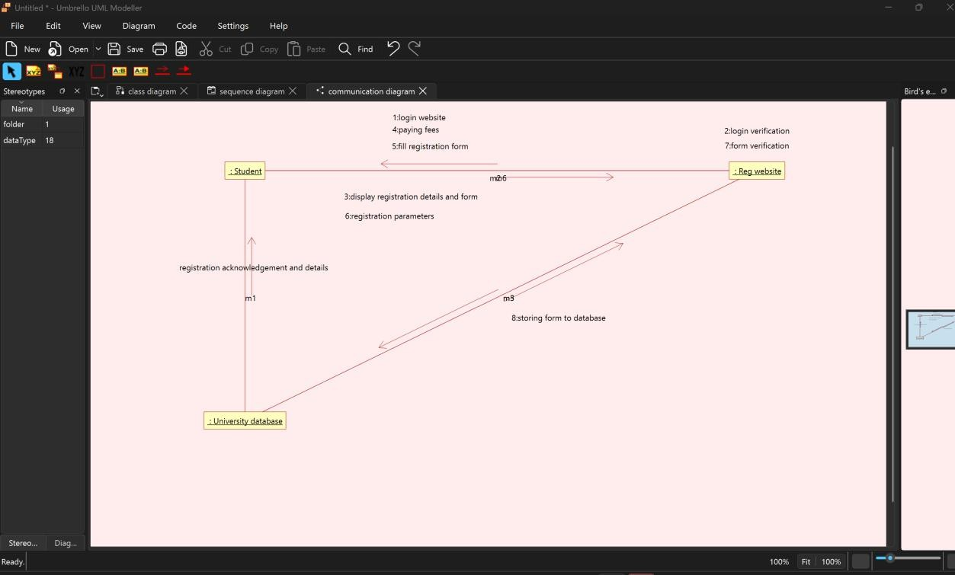

STATE CHART DIAGRAM

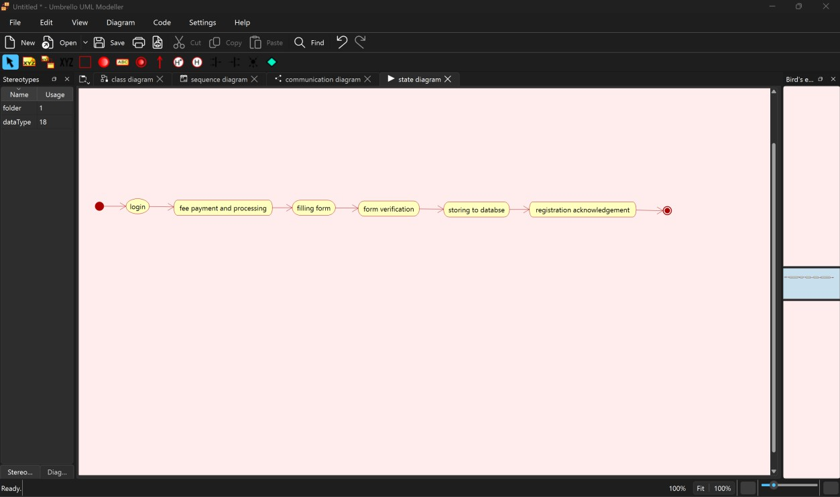

COMPONENT DIAGRAM:

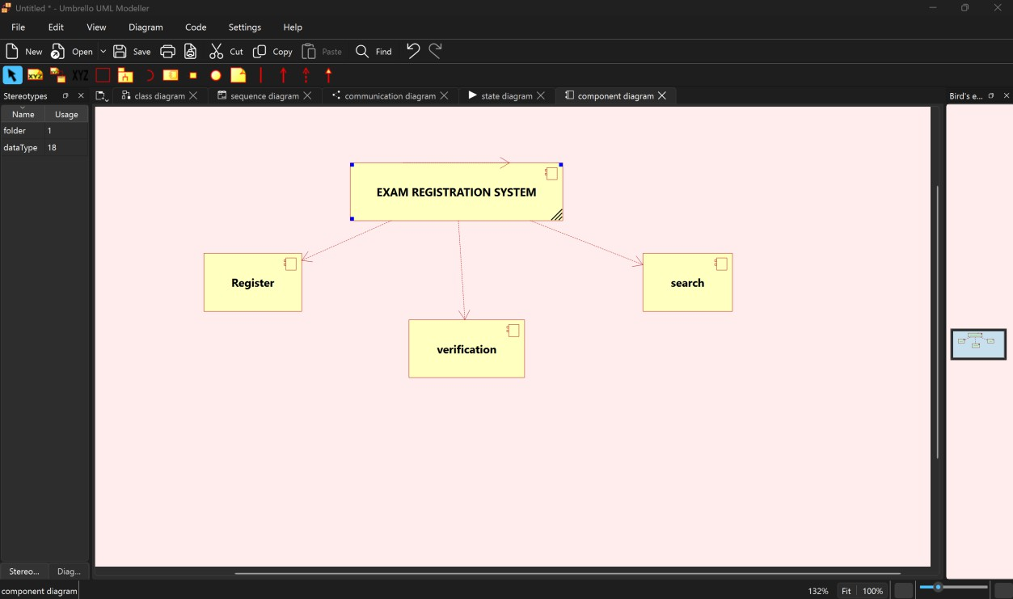

PACKAGE DIAGRAM:
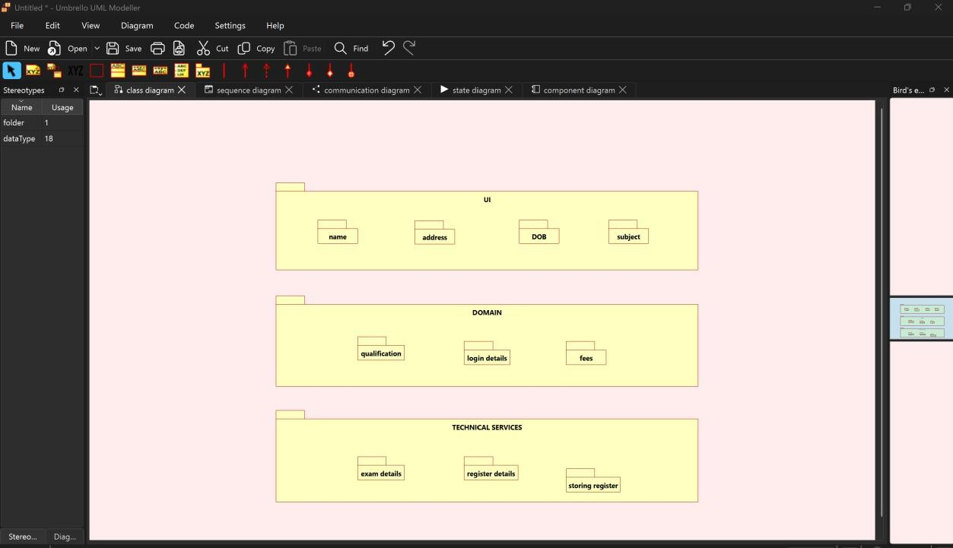

WEBPAGE FOR EXAM REGISTRATION SYSTEM

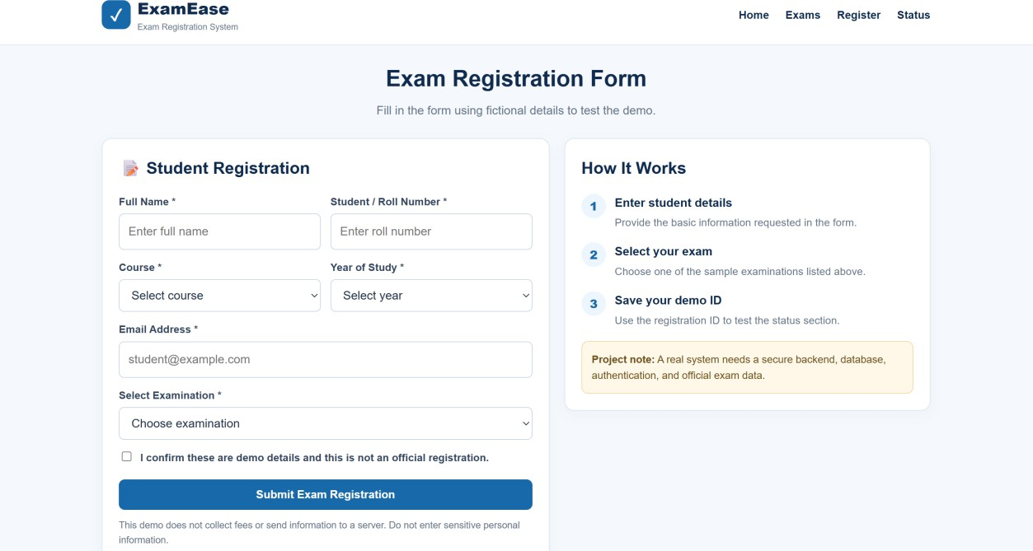

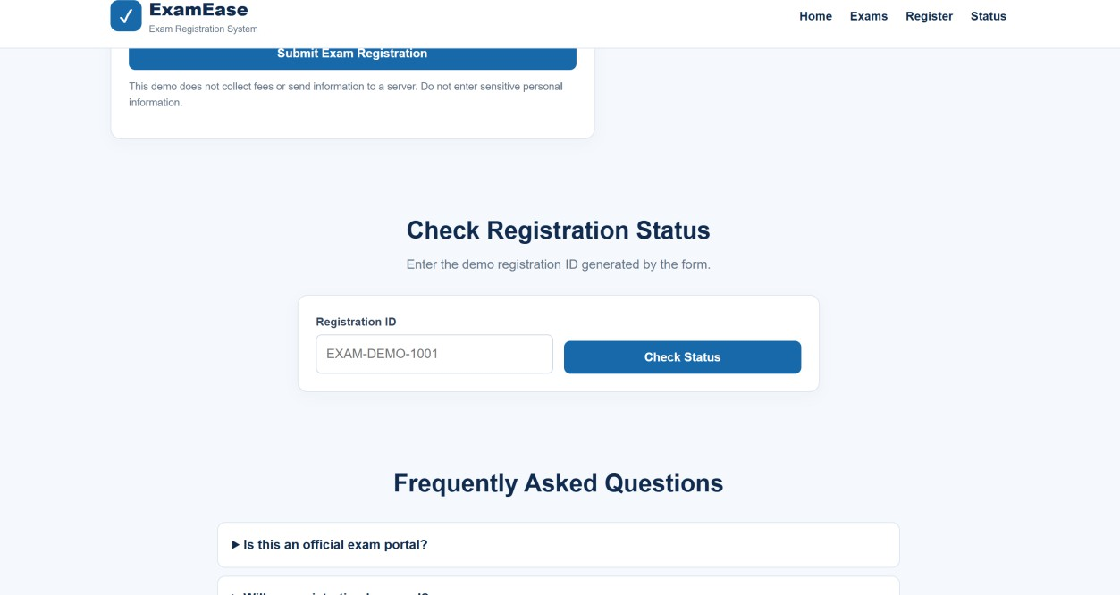

HTML CODE:

